Circadian Variation in Heart Rate and Blood Pressure during Sepsis

II. Methods

1. Study population
1.1 Data Source:
Data for this study was collected from the publically available Multiparameter Intelligent Monitoring in Intensive Care (MIMIC-II) database [x1], a repository of laboratory, physiological and outcome data collected from patients at the Beth Isreal Deaconess Medical Center between 2001 and 2008.
[x1] Saeed M, Villarroel M, Reisner AT, et al. Multiparameter Intelligent Monitoring in Intensive Care II (MIMIC-II): a public-access intensive care unit database. Crit Care Med 2011;39:952e60.
1.2 Study Population:
The subjects for this study were collected by querying the MIMIC-II database in the SQL programming language. We extracted two groups: a sepsis group and a non-sepsis group (control group). Patients admitted into the medical ICUs (MICU), surgical ICUs (SICU), coronary care units (CCU) and cardiac surgery recovery units (CSRU) with sepsis were included in the sepsis group. A subset of the patients admitted without sepsis was included in the non-sepsis group. The total number of sepsis admissions utilized in this study was 3837 with the median ICU length of stay being 5.3 days. After data pre-processing (detailed in section 2 below), there were 2722 admission records (of which, 2134 survived). As there are a large number of non-sepsis patients in the MIMIC-II database and the length of ICU stay is usually shorter than that of sepsis patients, we randomly selected 10,000 non-sepsis records from the MIMIC-II database as our non-sepsis group. This was later reduced to 3862 records (of which, 3597 survived) after the data pre-processing procedure outlined in the section 2, below.
1.3 Study variables and control variables
For the extracted two cohorts we collected a number of physiological variables to gauge the strength of the circadian rhythm. The four cardiovascular variables of interest were heart rate (HR), mean blood pressure (MBP), systolic blood pressure (SBP) and diastolic blood pressure (DBP). The MIMIC-II database contains two types of blood pressure measurements, which are available simultaneously or intermittently: invasive and non-invasive. Therefore, for each subject, we merged the invasive and non-invasive BP measurements due to fill-in gaps in the individual data streams. If the invasive measurements were available, we gave them priority due to their expected increase in accuracy.
As the median value of ICU length of stay is 5.3 days for the sepsis cohort, we extracted only up to the first 6 days of data for both sepsis group and non-sepsis group, regardless of a patient's total ICU length of stay. Our data set contains measurements for the cardiovascular variables measured every 0.5-1 hour. These measurements were verified by clinical staff during the collection process, and we therefore have no reason to doubt their integrity.
In addition to the cardiovascular measures, we also extracted several other variables that allowed us to partition and understand our cohort. These control variables included ICU mortality, admission age, and indicators for vasopressor and sedative drugs use. We used these control variables to partition our sepsis cohort into various subgroups, and analyzed the circadian variation of HR, MBP, SBP and DBP within each subgroup. For both the sepsis and non-sepsis groups, we explored the difference in circadian variation between the survival and non-survival subgroups.
2. Data pre-processing
2.1 Time series Alignment
It is necessary to align the time-dependent measurements for each record we collected from the database. To do this, we arbitrarily set 12:00 AM as the "zero-point" on the time axis, and aligned all the measurements from cardiovascular variables with respect to that starting point. The resolution of data available across patients varied (from several minutes to one hour). Hence, to allow for ease of comparison, we condensed the data across all patients into hourly measures by selecting the median value of the available measurements within each hour. The median value was chosen to help eliminate effects of measurement noise. Measures outside an physiologically likely range (HR and SBP: [20, 300], MBP and DBP: [20, 200]) or three standard deviation from the mean of the individual's corresponding signal were excluded as outliners. Linear interpolation with an hourly interval was used to construct artificial data points for patients with intermittent data gaps less than 4 hours.
2.2 Time-Frame Selection
For our study, HR and BP during the first 6-days of the ICU stay were selected and aligned. With this method, the aligned data on the first day and the last day are not reliable for analysis purposes due to the differences in admission and discharge time for each patient. Hence, to ensure reliable circadian rhythm analysis, we utilized only the data between days 2 and 5.
2.3 Patient records exclusion:
We excluded any patient records from this analysis with ICU stay length less than 1 day, or with less than 24 hours of available data. We also excluded patient records with large segments of data missing (more than 4 hours) during the ICU stay. This accounted for 9.47% of the original cohort.
2.4 Definition of daytime and nighttime periods
We used a data-driven approach and inferred the sleep and wake cycle on a population level using the fluctuations of the circadian rhythm. This process is necessary in our case, as the MIMIC-II database does not contain any indication of a patient's sleep state.
After time series alignment, we partitioned our sepsis cohort into a survival and non-survival subgroup. For each subgroup, we first computed the average hourly value of HR and BP across the subpopulation (see Figure 1) and called this $W_{k}$. These averaged signals were then used to define the "daytime" and "nighttime" periods for our study. More specially, we averaged the hourly signal values of $W_{k}$, across days. Let $h_{i}$ be the value of the signal at hour h, on day i, where $h= <1,2,3… 24>$ then we defined the average 24-hour waveform for each subgroup (see Figure 2), $W_{d}$ as:

$$W_{d}=\frac{\sum_{i=2}^{5}{h_{i}}}{4}$$

The nighttime interval was selected as an 8hr window around the minimum of $W_{d}$, classifying the remaining hours as daytime.
The single cosinor method was performed on $W_{d}$ to check for circadian variations at the subpopulation levels. The single cosinor method is a traditional mathematical waveform modeling method performed in the time domain, which was widely used in rhythmometric analysis. With the single cosinor method, circadian rhythm is often defined by three parameters: MESOR, amplitude, and acrophase [x2]. We used the amplitude parameter as a proxy for the strength of circadian variation, and the MESOR parameter to represent the average value of HR and BP. These results are presented in section III.
[x2] Fernández JR, Hermida RC, Mojón A. Chronobiological analysis techniques. Application to blood pressure. Philos Transact A Math Phys Eng Sci. 2009 Jan 28;367(1887):431-445.

2.5 Calculation of day-night reduction
For each individuals HR and BP values, we calculated the difference in the median value between the above defined daytime and nighttime periods, and we defined this difference as the day-night reduction. For patients with more than one day-night reduction available because of several days of ICU stay, we used the median value. To eliminate the affecting factors (such as trends and noise) and improve the reliability of our results, we applied a band pass filter [x3] and extracted the circadian variation component from each individual data. The band pass filter used in our study was a resonant (single pole) filter with a resonant frequency of 24 hours. The Q factor in our case was set to 0.8, as large values will introduce false oscillation and small values cannot remove the trends effectively.
[x3] Engelberg, S. Precise variable-Q filter design. IEEE SIGNAL PROC. MAG. 2008(5), 113 - 119.
2.6 Adjustment of age
As we expected age to be a confounding factor for circadian variation (with older participants showing reduced amplitude of circadian rhythm [x4,x5]), we adjusted our analysis to account for the age of patients. To do this, we investigated the relationship between day-night reduction and age. All patients were divided into four groups according to their ICU admission age: less than 40, from 40 to 60, from 60 to 80 and larger than 80. The mean day-night reduction value of each group was then calculated for each cardiovascular variable. If age had a significant influence on the day-night reduction (according to one-way ANOVA analysis), each individuals day-night reduction was adjusted according to the age. [EXPLAIN for methodology paper]
[x4] Duffy J. F., Czeisler C. A. (2002). Age-related change in the relationship between circadian period, circadian phase, and diurnal preference in humans. Neurosci. Lett. 318, 117–120
[x5] Nakamura T. J., Nakamura W., Yamazaki S., Kudo T., Cutler T., Colwell C. S., Block G. D. (2011). Age-related decline in circadian output. J. Neurosci. 31, 10201–10205

3. Statistical analysis
To test the difference in day-night reduction between survival and non-survival subgroups, we first performed a normality test (Kolmogorov-Smirnov test) on each subgroup. As the result did not support the normal distribution assumption, we then used the Wilcoxon rank sum test to check the significance of difference between the subgroups. Unbalanced one-way ANOVA was performed in the process of age adjustment with p-value <0.05 indicating age has significant influence on the value of day-night reduction, and the result should be adjusted for age. All statistical analyses were performed using MATLAB version R2010b (MathWorks, Natick, Massachusetts, USA).

III. Results
1. Circadian variation at population level
Figure 1 shows the average hourly value of HR and MBP ($W_{k}$) for the sepsis cohort, partitioned further into survival and non-survival subgroups. From Figure 1 it can be seen that for the survival subgroup, both HR and MBP present a circadian rhythm during the first 5-days of the ICU stay. We note here however that the amplitude of circadian rhythm is far weaker for the non-survival subgroup. Similar results were found in both SDP and DBP time series from the first 5-days of ICU stay.

Figure 1: A Comparison of HR (a) and MBP (b) for Sepsis, survival and non-survival subgroups
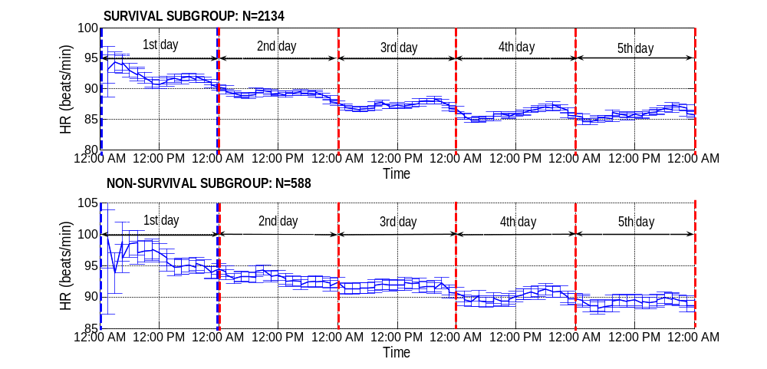
(a) HR
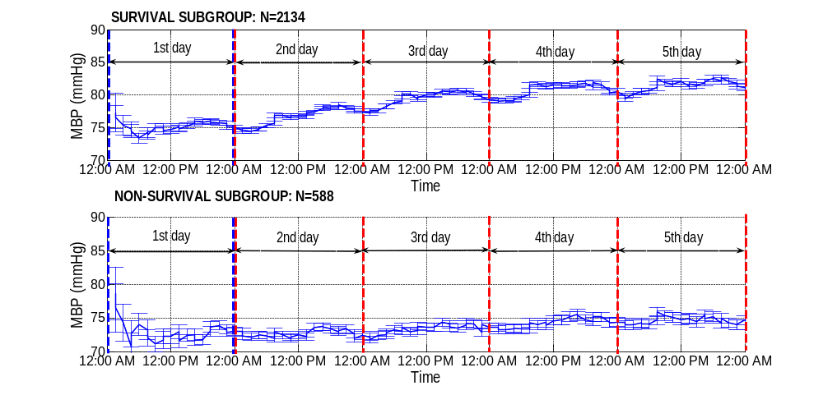
(b) MBP
SURVIVAL GROUP
The plot represents the mean values of HR and MBP for the sepsis group for the first 5 days in the hospital, with error bars representing the standard error (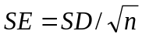 ,where n is the number of the subject).
The results of average hourly values for the sepsis group from day 2 to day 5 ($W_{d})$ for HR, MBP, SBP and DBP are shown in Figure 2. The amplitude and MESOR of the survival and non-survival members of the sepsis group are shown in Table 1. We verified that for both HR and BP, the amplitude of the circadian rhythm of the survival subgroup in $W_{d}$ was larger than that of the non-survival subgroup. In addition to amplitude, the MESOR parameter is also different between survival and non-survival subgroups, with patients in the survival subgroup exhibiting a relatively higher average BP and lower HR.
It is necessary to note that viewing the hourly change of HR and BP at the subpopulation level helps us confirm the existence of the circadian rhythm. The method of single cosine fitting on the subpopulation level just provided us an estimate about the circadian variation between subgroups, more accurate circadian variation analysis, based on individual data, are presented later in this section.

Figure 2: Four-day average hourly data, $W_{d}$ for HR, MBP, SBP and DBP
The solid lines represent the averaged values for each variable, and the dotted lines represent the curves of single cosine function fitting for each time series. Red lines indicate data from survival subgroup, and blue lines indicate data coming from non-survival subgroup.

Table 1: Amplitude and MESOR of the single cosine function fitting between survival and non-survival subgroups.

Cardiovascular variables | Survival |  | Non-survival
Cardiovascular variables | Amplitude | MESOR | Amplitude | MESOR
HR | 0.54 | 87 | 0.21 | 91
MBP | 1.24 | 80 | 0.60 | 74
SBP | 1.79 | 120 | 0.81 | 111
DBP | 0.98 | 60 | 0.41 | 56

2. Daytime and nighttime periods
Form the subpopulation data in Figure 2, we can tell that the local minima of the 24 hours of averaged HR and BP is around 2:00 AM, therefore, the definition of night-time should fall between the hours of 10:00 PM to 6:00 AM ( 2:00 AM ± 4 hours ), with all other hours signifying daytime. This result is encouraging as it matches our intuitions about when a normal person's sleep and wakefulness periods should occur. With this definition, we can further calculate the day-night reduction for each individual, and check the differences between the survival and non-survival subgroups.
3. Day-night reduction between survivors and non-survivors
For individual data, we used a band pass filter to extract the circadian variation component and calculated the day-night reduction according to the defined daytime and nighttime periods. Table 2 shows the result of the sepsis cohort and non-sepsis cohort without age adjustment.
Table 2: Amplitude difference in circadian variation between survival and non-survival subgroups without age adjustment.
Day-night reduction | Survival  Median [1st Q, 3rd Q] | Non-survival  Median [1st Q, 3rd Q] | P value
Sepsis cohort (n=2722) | n=2134 | n=588
HR | 0.90 [-1.60, 3.71] | 0.50 [-2.24, 3.24] | 0.012
MBP | 1.61 [-1.02, 4.47] | 0.58 [-1.92, 2.79] | <0.01
SBP | 2.20 [-1.60, 6.25] | 0.59 [-2.90, 4.36] | <0.01
DBP | 1.29 [-0.93, 3.64] | 0.44 [-1.71, 2.38] | <0.01
Non-sepsis cohort (n=3862) | n= 3597 | n=265
HR | 1.01 [-1.77, 4.20] | 0.59 [-2.15, 3.74] | 0.109
MBP | 1.84 [-0.98, 5.01] | 1.02 [-2.12, 4.19] | <0.01
SBP | 3.07 [-1.21, 7.70] | 2.06 [-2.18, 5.98] | <0.01
DBP | 1.29 [-1.11, 3.95] | 0.85 [-1.69, 3.40] | 0.026

As age is a confounding factor to circadian variation, we further adjusted the results for age. Figure 3 shows the relationship between day-night reduction and the distribution of age for HR and MBP. Table 3 shows the result of a one-way ANOVA test between the 4 age groups defined in section II. From Table 3 we can see that age has a significant effect on circadian variation for both HR and BP. Our results confirm that day-night reduction gets smaller with increasing of age.
Figure 3: Relationship between day-night reduction and the age for HR and MBP
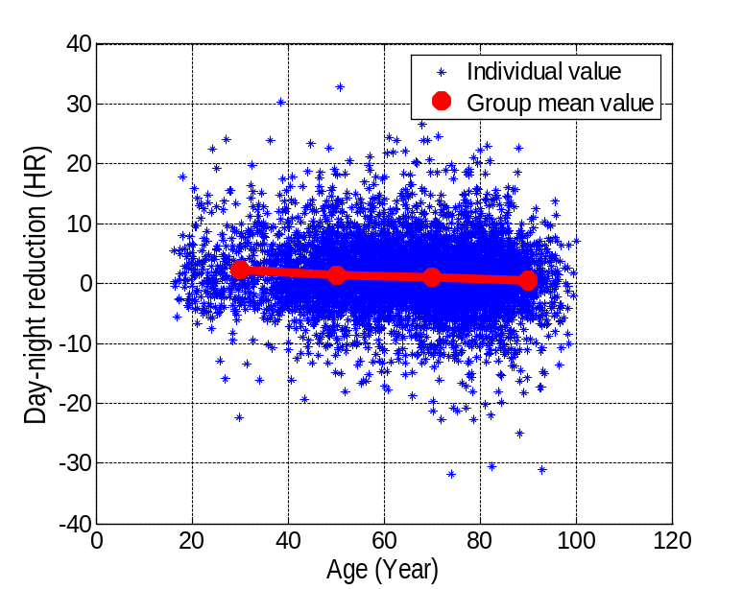
(a) HR
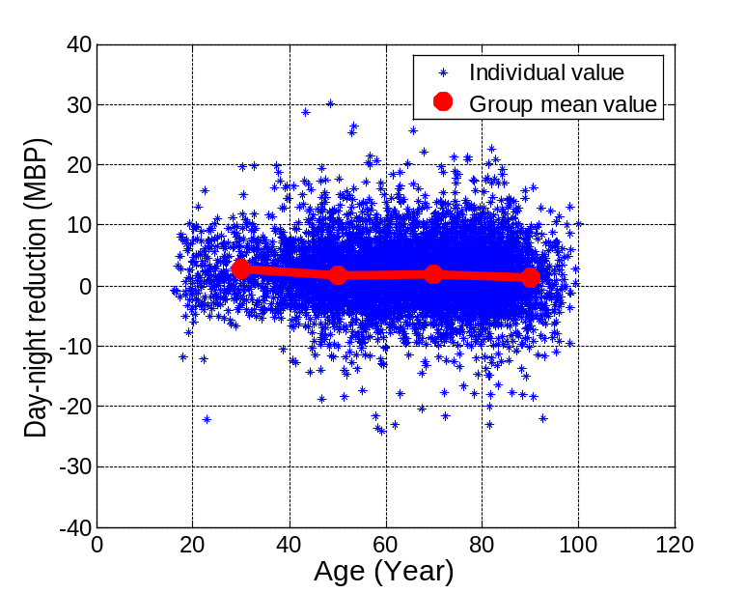
(b) MBP
Table 3: The mean values of the four age group and the results of ANOVA analysis
Cardiovascular variables | Age distribution |  |  |  | P value
Cardiovascular variables | <40 | 40~60 | 60~80 | >80 | P value
HR | 2.26 | 1.39 | 1.07 | 0.59 | P<0.01
MBP | 2.72 | 1.75 | 1.88 | 1.34 | P<0.01
SBP | 3.54 | 2.53 | 2.93 | 2.45 | 0.011
DBP | 2.31 | 1.35 | 1.39 | 0.91 | P<0.01
Table 4 shows the results of circadian variation after age adjustment. It can be seen that the amplitude of circadian variation among survival and non-survival subgroups both decreased after age adjustment. For the sepsis group, there is still a significant difference between survival and non-survival subgroups for all variables, for the non-sepsis group, the amplitude of circadian variation among the survival members is still larger than that among non-survival members, however, only BP exhibits a statistically significant difference between survival and non-survival subgroups.

Table 4: The results of circadian variation after age adjustment
Day-night reduction | Survival  Median [1st Q, 3rd Q] | Non-survival  Median [1st Q, 3rd Q] | P value
Sepsis cohort (n=2722) | n=2134 | n=588
HR | 0.54 [-1.99, 3.36] | 0.20 [-2.68, 2.97] | 0.024
MBP | 1.33 [-1.25, 4.19] | 0.28 [-2.28, 2.50] | <0.01
SBP | 1.94 [-1.81, 5.99] | 0.34 [-3.10, 4.14] | <0.01
DBP | 0.99 [-1.18, 3.39] | 0.19 [-1.89, 2.16] | <0.01
Non-sepsis cohort (n=3862) | n= 3597 | n=265
HR | 0.64 [-2.16, 3.87] | 0.29 [-2.55, 3.47] | 0.254
MBP | 1.54 [-1.29, 4.71] | 0.77 [-2.45, 3.90] | 0.012
SBP | 2.82 [-1.45, 7.43] | 1.66 [-2.37, 5.83] | <0.01
DBP | 1.03 [-1.44, 3.65] | 0.75 [-1.76, 3.28] | 0.046

4. Effect of vasopressors and sedative drugs on circadian rhythm
As vassopressors and sedative drugs are common medications to sepsis patients, we further investigated the effects of vasopressors and sedative drugs on circadian variation in the sepsis group.
Table 5 compares the difference in day-night reduction between the survival and non-survival members of the sepsis group who used vasoprssors or sedative drugs. From Table 6 it can be seen that there is a significant difference between survival and non-survival members in both HR and BP, which indicates that ICU outcome is the dominant factor affecting the strength of circadian variation.
Table 5: Difference in the amplitude of circadian variation between survival and non-survival subgroups among sepsis patients on vasopressors and sedative drugs
Day-night reduction | Vasopressors |  | P value
Day-night reduction | Survival (n=1201)  Median [1st Q, 3rd Q] | Non-survival (n=536)  Median [1st Q, 3rd Q] | P value
HR | 0.60 [-1.93, 3.34] | 0.10 [-2.73, 2.87] | 0.012
MBP | 1.03 [-1.34, 3.73] | 0.25 [-2.25, 2.44] | <0.01
SBP | 1.58 [-1.90, 5.42] | 0.40 [-3.16, 4.15] | <0.01
DBP | 0.82 [-1.21, 3.05] | 0.17 [-1.88, 2.06] | <0.01
 | sedative drugs
 | Survival (n=1102)  Median [1st Q, 3rd Q] | Non-survival (n=454)  Median [1st Q, 3rd Q]
HR | 0.48 [-1.90, 3.11] | 0.15 [-2.89, 2.76] | 0.030
MBP | 1.15 [-1.26, 3.94] | 0.27 [-2.23, 2.48] | <0.01
SBP | 2.03 [-1.79, 5.90] | 0.53 [-3.09, 4.16] | <0.01
DBP | 0.81 [-1.21, 3.06] | 0.15 [-1.89, 2.26] | <0.01

Preliminary Conclusions
1. We verified that the circadian variation exists and behaves differently for survival and non-survival groups, both for sepsis patients and non-sepsis patients. Specifically, we observed a statistically significant difference between the SBP, DBP and MBP between the two subgroups with the circadian rhythm of the non-survived subgroup being far weaker than that of the survival subgroup. The HR amplitude difference between survivor and non-survivor is not as significant as that of BP. The difference in HR between survivor and non-survivor was statistically significant only in the sepsis group
2. We observed that regardless of patients vasopressor and sedative drug use, there was a significant difference in day-night reduction of both the HR and BP between survivor and non-survivor members of the sepsis group.
3. Even though the circadian rhythm exists for survival sepsis patients, the amplitude of day-night reduction is relatively small.

